Presented By: Chainika Dongre Date: 22/05/2025

📄 Wi-Fi Security Assessment

1. Introduction
Home Wi-Fi networks are often targeted by attackers aiming to exploit weak passwords, open services, or unencrypted traffic. This report documents a comprehensive wireless security assessment using the essential tools available in Kali Linux: Wireshark for network traffic analysis and Nmap for port scanning and device discovery. These tools simulate real-world attacks and highlight potential vulnerabilities, enabling better defense against intrusions.

2. Tools Used:
- Wireshark
- Nmap

3. Objective: Analyze the security of a home Wi-Fi network by inspecting traffic, scanning for open ports, and identifying connected devices.

4. Methodology:
4.1 Wireshark for network traffic analysis:
- Open Wireshark
- Monitored packets on wireless interface.
- Traffic types: DHCP, DNS, HTTPS, HTTP.
- All login and banking pages used HTTPS encryption.
- No credentials or sensitive info exposed.

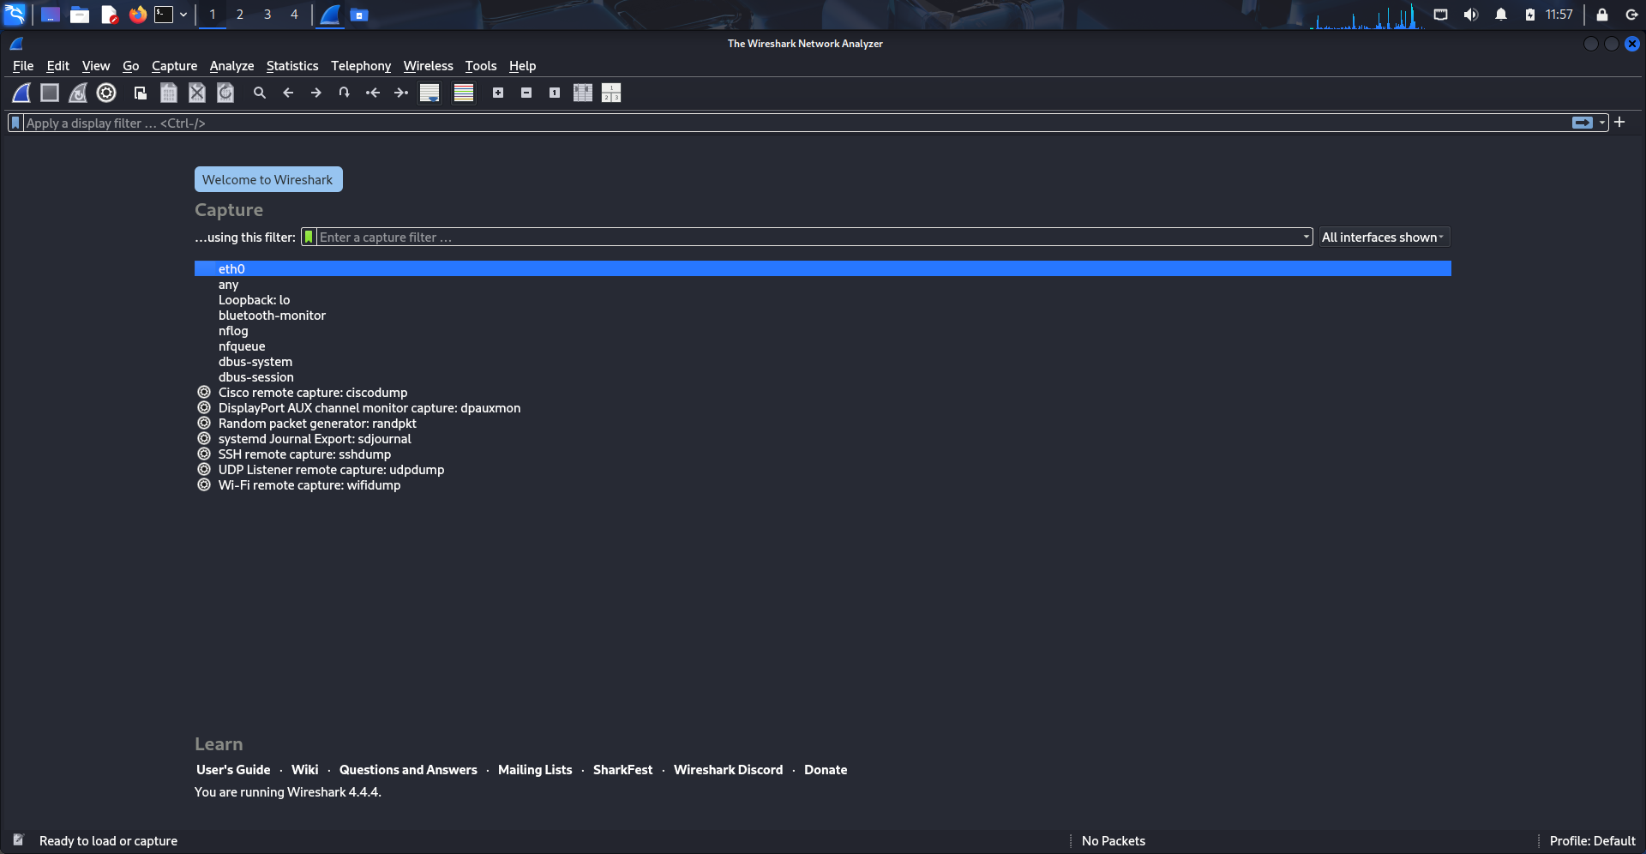
- Filtered Packets to check the risks:
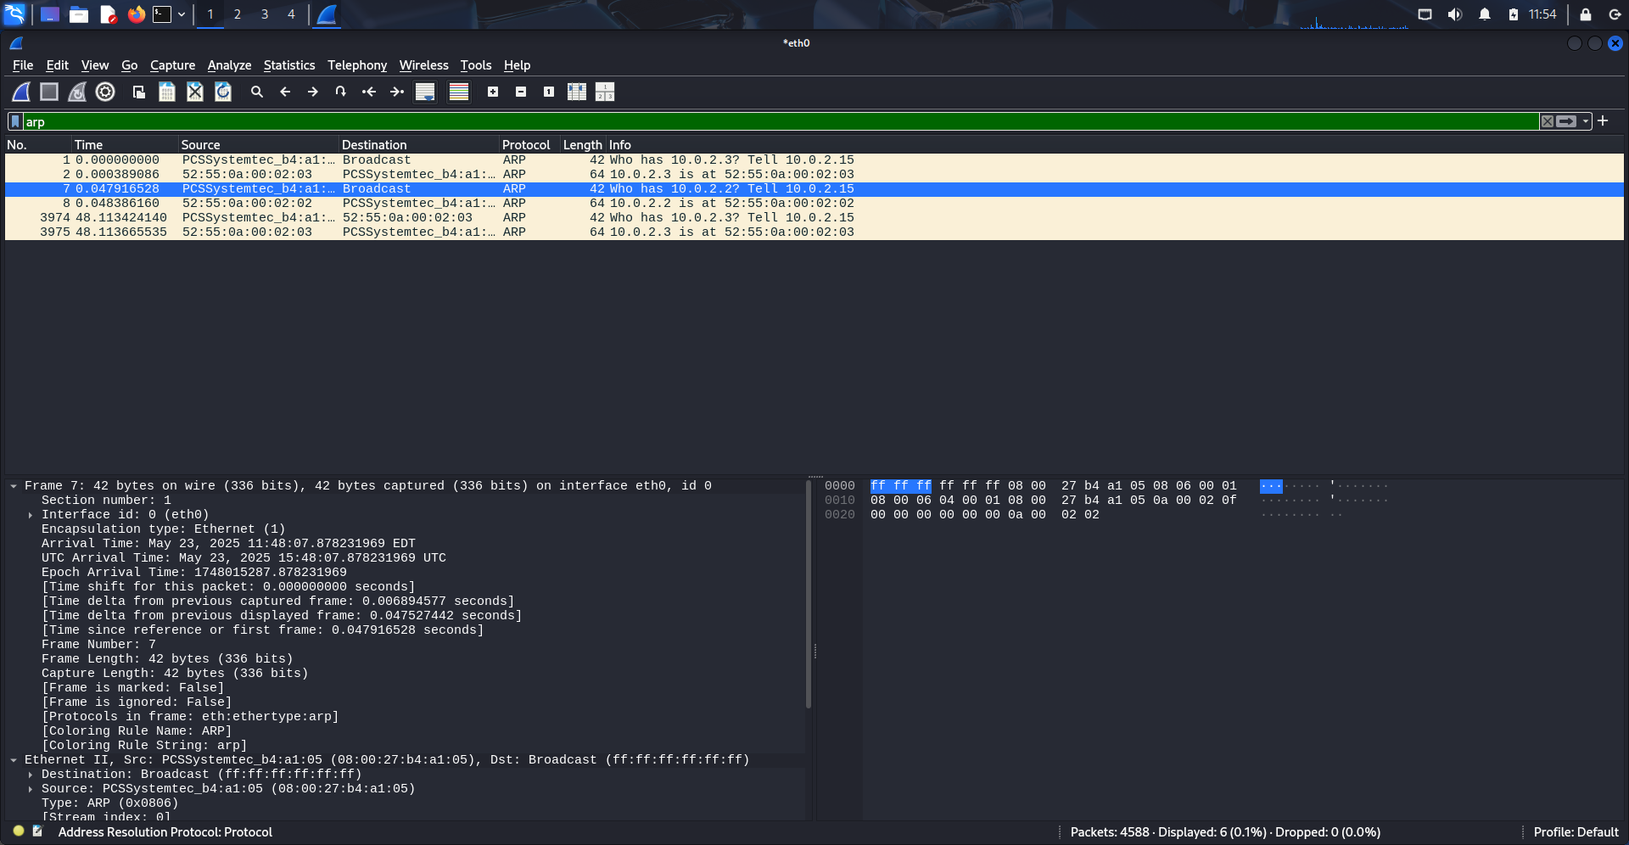
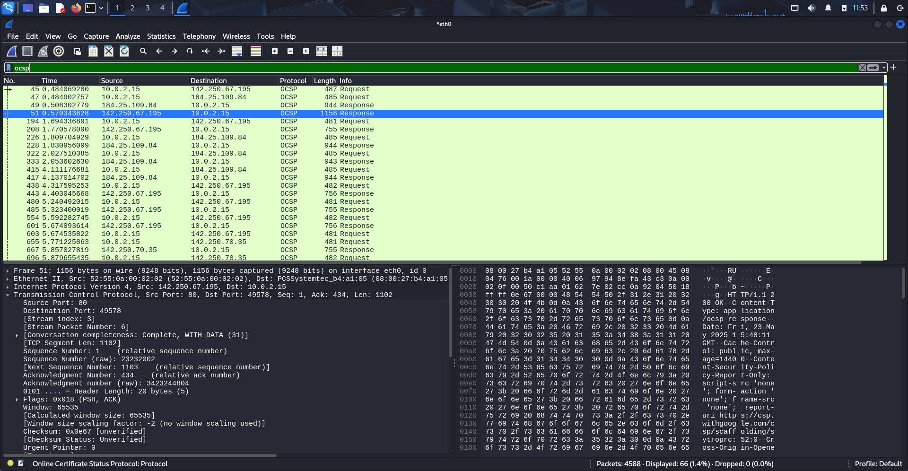
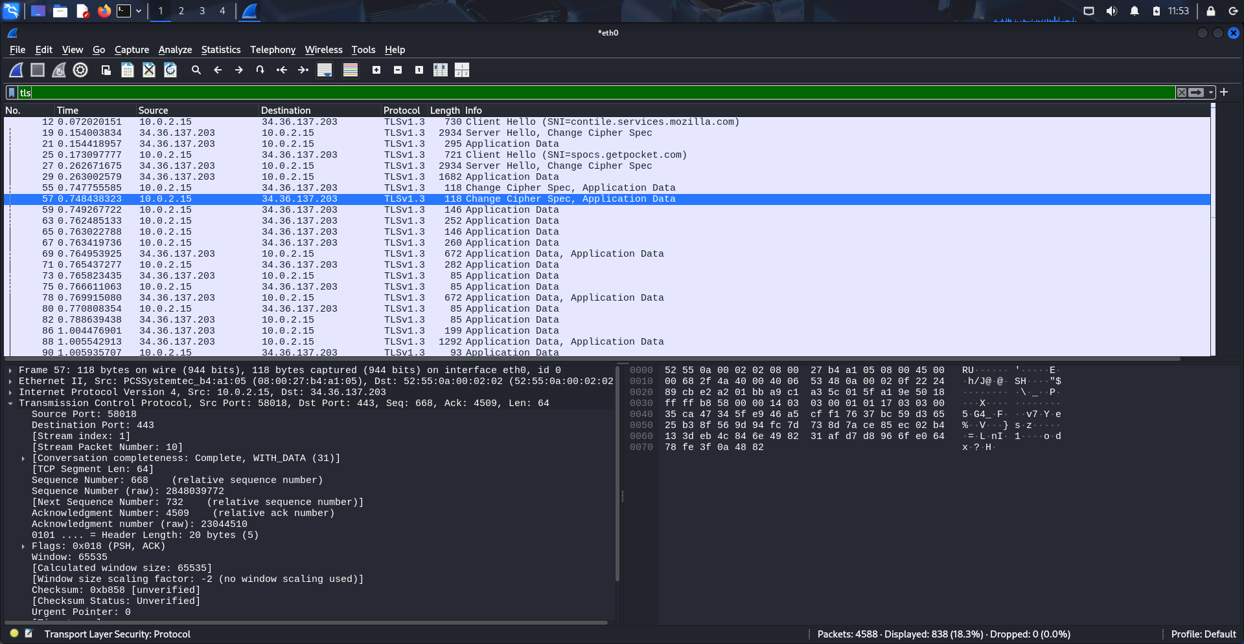
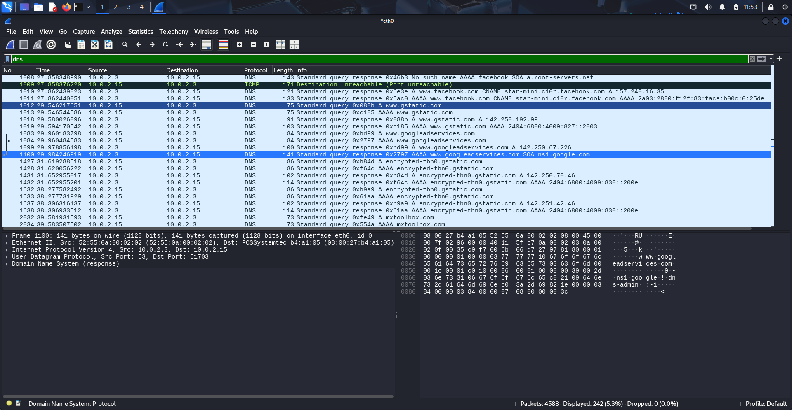
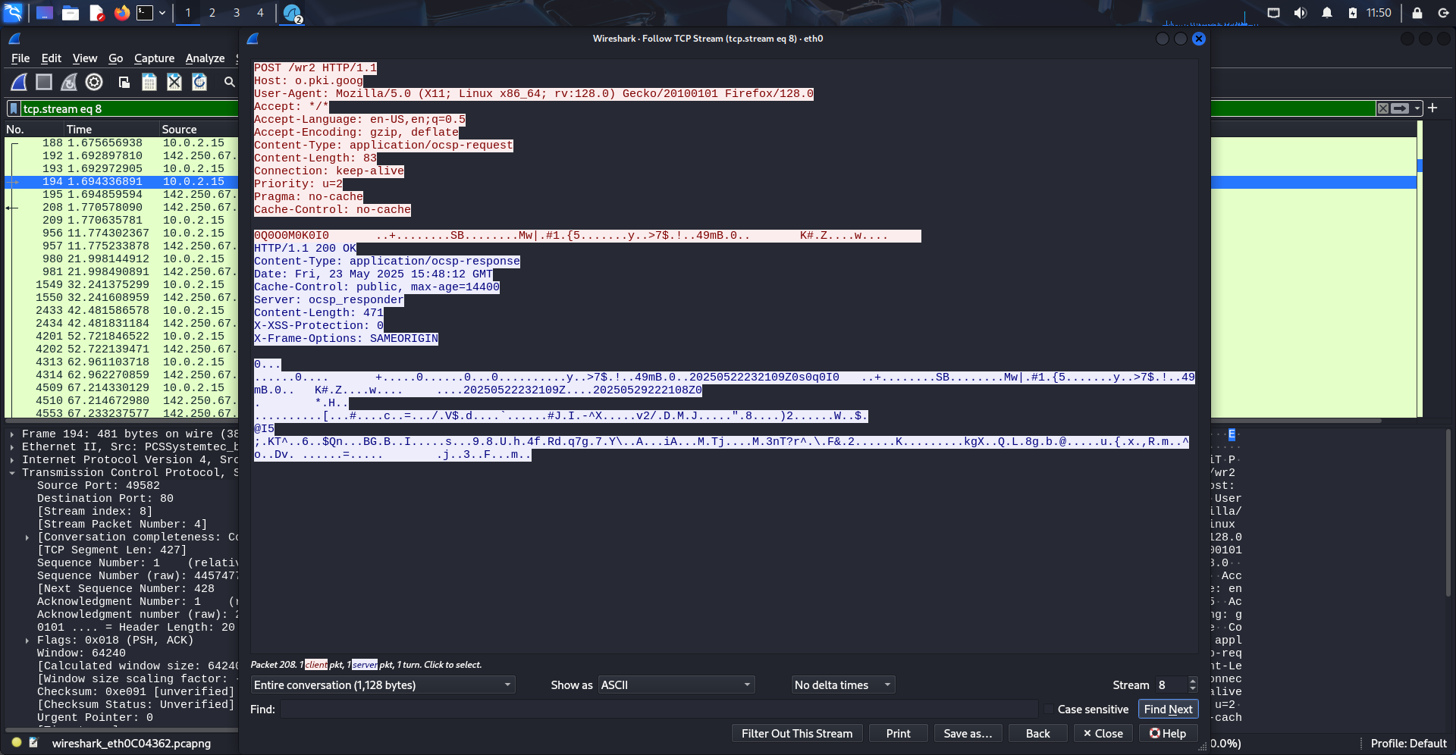
- Above Viewed detailed information of the filtered packets
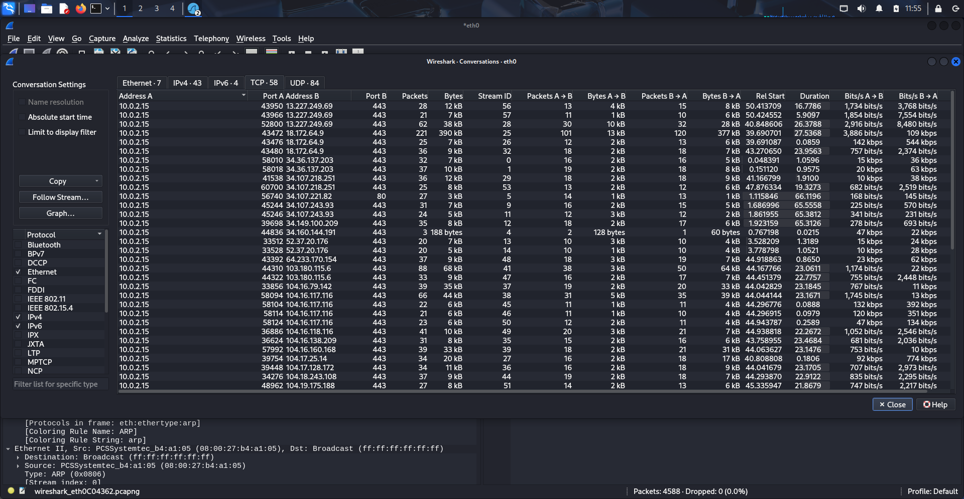
- Checked the communication between all the devices. The Wireshark conversation statistics show various connections originating from IP 10.0.2.15 to multiple external IPs, primarily over port 443 (HTTPS). Key metrics include packet counts, bytes transferred, and duration.
- Key Observations:
- The top conversations are over port 443, indicating encrypted HTTPS traffic.
- Large volume of traffic in some connections may indicate sensitive data exchange.
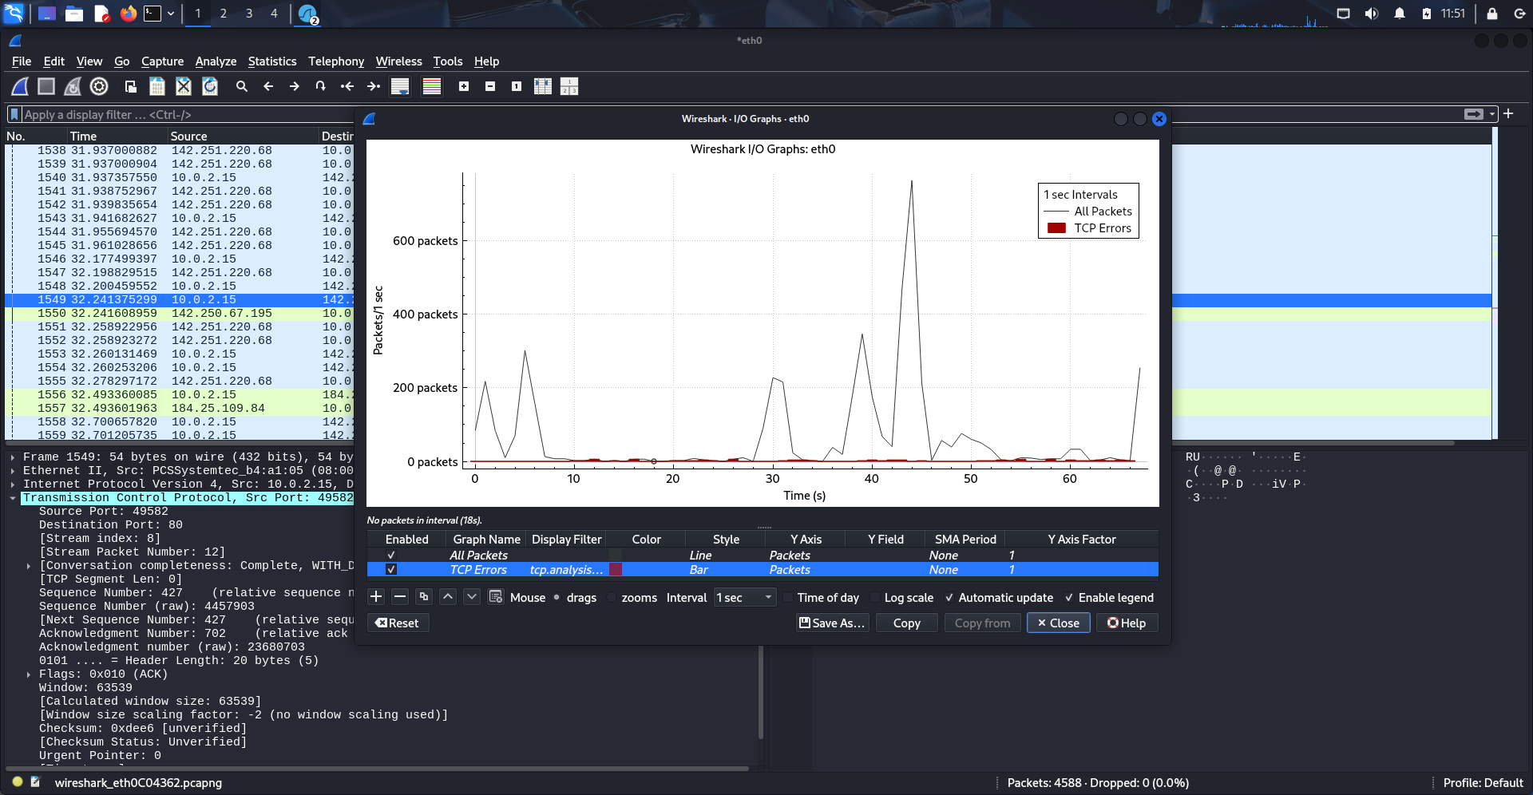
- The I/O graph plotted for interface eth0 visualizes all packets and TCP errors over time intervals.
- Analysis:
- Sudden spikes in traffic volume could indicate large downloads or possible file transfers.
- Consistent low-level TCP errors may indicate retransmissions or malformed packets.

📊 Results:
- Captured live packets on the wireless interface.
- Observed DNS, OCSP, TLS and HTTP traffic.
- Looked for anomalies such as ARP spoofing, repeated SYN packets, or unusual destinations.

🔍 Findings:
- No unencrypted sensitive data detected.
- No evidence of ARP poisoning or rogue DHCP servers.
- Encrypted TLS traffic observed.
- No sensitive data in plaintext.
- Traffic to multiple external IPs.
Recommendation:
- Block or monitor unauthorized outbound IP connections via firewall or router logs.
- Avoid using unsecured protocols like HTTP, FTP, Telnet — use HTTPS, SFTP, SSH only.
- Disable legacy protocols (FTP, Telnet).
- Use VPN when accessing the internet over Wi-Fi.
- Monitor High Volume Hosts: Repeated contact with certain IPs should be reviewed for policy compliance.
- Periodic Packet Reviews: Regular analysis of packet captures can uncover early signs of misconfigurations or threats.

4.2 Network Scanning (Nmap):

Observations:
- Target Subnet: 10.0.2.0/24
- Active Hosts Detected:
  - 10.0.2.2 — Multiple open ports:
    - 135/tcp – Microsoft RPC
    - 445/tcp – Microsoft-DS (Windows SMB)
    - 4449/tcp – Privatewire
    - 6646/tcp – Unknown
    - 10000/tcp – Network sensor or management service
  - 10.0.2.3 — Online, but no open TCP ports detected
  - 10.0.2.15 — Online, all scanned ports closed
- MAC Addresses were identified for devices 10.0.2.2 and 10.0.2.3.

Findings:
- One device (likely the host system or VM) had several open ports, including some associated with remote access (e.g., TCP 4444).
- Other two hosts were less exposed:
  - One had no detectable open ports.
  - The other had all ports closed.
- No unexpected or unauthorized devices detected on the subnet.
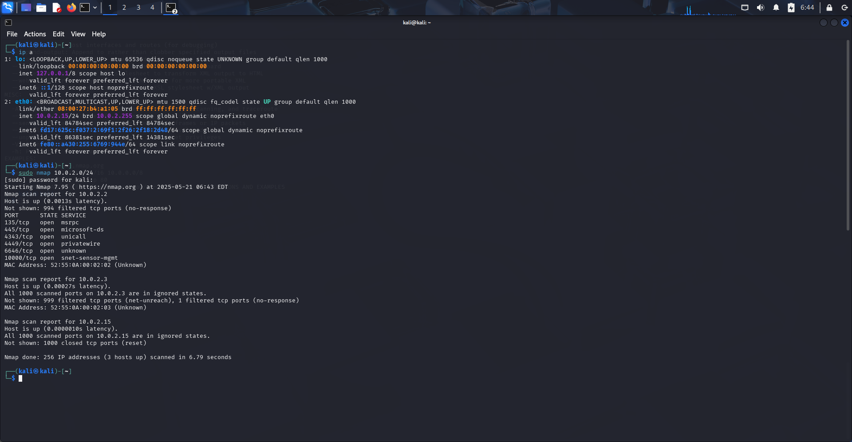
5. Recommendations
- Change default router credentials immediately if not already done.
- Use strong Wi-Fi passwords with at least 12 characters, including uppercase, lowercase, numbers, and symbols.
- Enable WPA3 encryption if your router and devices support it. Otherwise, use WPA2 with AES (CCMP) only.
- Disable WPS (Wi-Fi Protected Setup) to prevent brute-force attacks.
- Enable MAC address filtering to restrict access to known devices.
- Use a VPN for extra security while accessing the internet.

Conclusion
The Wi-Fi security assessment of the home network using Wireshark and Nmap revealed a generally well-configured environment with encrypted traffic and minimal exposure to external threats. Network traffic analysis confirmed the use of secure HTTPS connections for sensitive activities, and no unencrypted credentials or malicious behavior were observed during the packet capture. Nmap scans showed that only one host had multiple open ports, which should be further reviewed to ensure they are necessary and secured.
No unauthorized devices or signs of ARP spoofing, rogue DHCP servers, or plaintext data transmission were detected. However, the presence of legacy ports and unnecessary services presents a minor risk that can be mitigated through proactive hardening measures.
By implementing the recommended actions—such as updating passwords, disabling insecure protocols, and regularly reviewing network activity—the home network can maintain a strong defense against common wireless threats.

